PUBLIC AFFAIRS MEMO
An update from SWFWI Public Affairs Committee
November 2021 / Issue 2
Together we can make a real difference

Welcome to the second PA Committee Memo. These memos are ongoing information sheets about the different campaigns on which the WI have a mandate to raise awareness around. We will keep you up to date with any current news on the Resolutions via this memo, the Hive and on the SWFWI website (under the Resolutions tab) and aim to give you ideas of how to get involved either yourselves or at your own WI. We hope these memos will make the issues raised a little more relevant to you. This edition focuses on some of the WI’s health resolutions and campaigns.

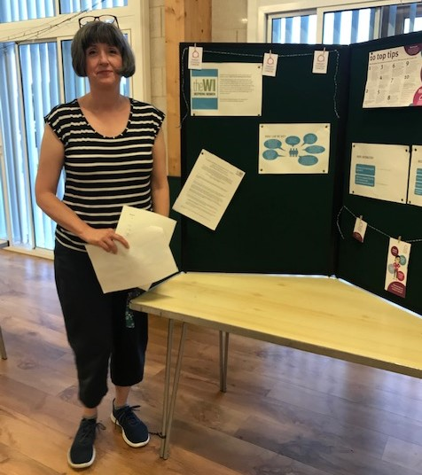
A call to increase awareness of the subtle signs of ovarian cancer
Honington and Sapiston WI - The first full meeting back happened on 11th August 2021
where it was decided to hold table discussions with the members regarding the latest
resolution on increasing the awareness of the subtle signs of ovarian cancer. The discussion was initiated by a committee member reminding members of the resolution and the ways WIs could assist and then the WI quiz on ovarian cancer was used to start discussions on the tables alongside, information from the target ovarian cancer charity. Members were concerned with the statistics on the quiz and suggestions for ideas to promote this will be discussed at a future committee meeting. Immediate suggestions were to leave some leaflets in the village hall, discuss with local patient’s association at the doctor’s surgery and holding a coffee morning to promote this. A board was created of information for members to review during coffee time. Joanne Hoyle Assistant Secretary Honington and Sapiston WI

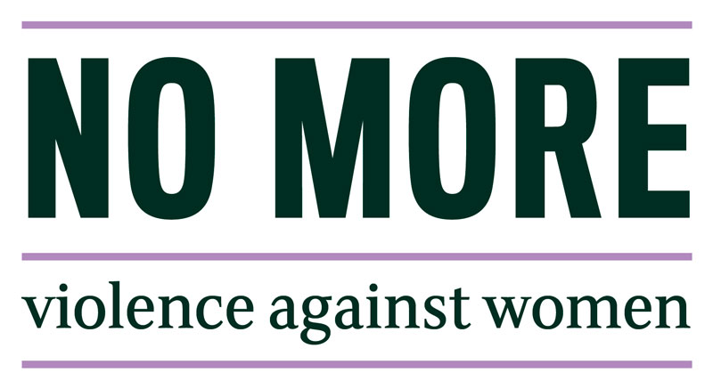
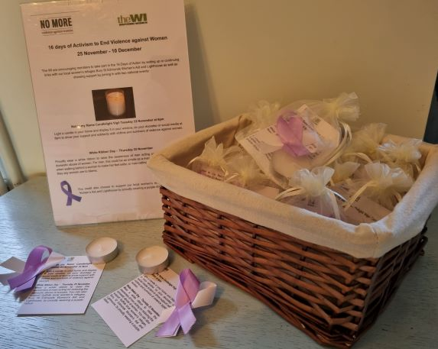
As part of the 2021 ‘16 Days of Action against Violence to Women’, Moreton Hall WI, at its November meeting, meeting gave its members a bag with a candle, white and purple ribbon and a card with details of the ‘Not in my Name Candlelight Vigil’ on Tuesday 23 November at 6pm and ‘Wear a white ribbon day’ on 25th November. Purple ribbons are in support of the Bury Women’s Aid and Ipswich Lighthouse.
NFWI will be hosting a webinar during the 16 days on 10th December 2021, where you will be able to learn more about the issue from expert speakers, including the role that men can play in ending violence against women. More details of the event and how to register are on MyWI under the Campaigns tab.

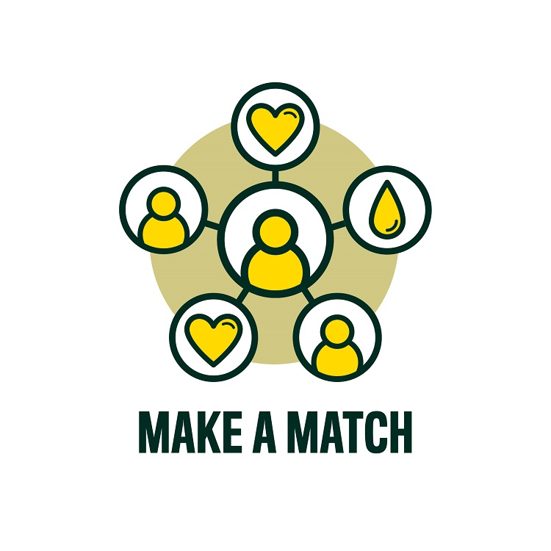
One of the WI Resolutions for 2019/20 called for members to increase potential Stem Cell donor registration. NFWI has worked with Anthony Nolan and DKMS to create WI specific sign up links to the stem cell registry, which you can use yourself or share with those around you. These links will allow us to keep track of the number of people that sign up as a potential donor as a result of our Make a Match campaign. DKMS/WI Signup link: www.dkms.org.uk/thewi
Anthony Nolan/WI Signup link: www.anthonynolan.org/WI
“It’s such a relatively easy donation to give, but the end result is truly wonderful” Eirwen Phillips, Secretary of Kedington WI

5 Minutes that Matter - Its good to talk about it…!
97% of delegates voted in support of the 2019 resolution calling on WI members to raise awareness of the importance of cervical screening and help to address barriers to attendance.
While it’s not a test for cancer, regular cervical screening (also referred to as a ‘smear test’) is the best way for abnormal cells to be picked up early and treated (if necessary) to prevent cancer developing. It is estimated that the test currently prevents 70% of cervical cancer deaths. However, this figure could be 83% if all eligible women attended. Cervical screening is a choice, and attendance is currently at a 21-year low.
The WI campaign seeks to support more women in making an informed decision about whether or not to take up their cervical screening invitations. We can all help to challenge the myths around cervical screening by speaking at WI meeting, to friends and family about the test and why it’s important to have a cervical smear test.

You can find out more on the MyWI website about the WIs past health campaigns such as: Make Time for Mental Health Time to Talk about Organ Donation, Care Not Custody, Carers Welcome, Link Together, Time to Talk, More Midwives, Time to Talk about Organ Donation – along with free materials to download and/or sent for to help with raising awareness and/or campaigns.

Do you feel strongly about an issue? Then submit a WI RESOLUTION!

Hello, I am Brenda Dyer, your Federation Resolution Adviser.

If you or your WI have a topic or issue about which you or your WI feels very keenly about, you could think about putting in a resolution for 2022/23. I can guide you through the process and ensure the resolution does not duplicate any resolutions that have already been passed. The WI has covered many topics in its 100+ years and in order to maximise your success in being selected, your resolution should be topical and strongly worded.

SWFWI’s Shortlist Zoom Resolution Briefings are on 29th November, 10.30am and 7.30pm. Both sessions will be the same, so members are encouraged to attend just one of the briefings. Contact the office to register your place. A zoom link will be sent to you nearer the date. This year’s resolution process will run through to the NFWI’s Annual Meeting in June 2022 and then we will start with freshly submitted resolutions.

Brenda Dyer
Federation Resolution Adviser
Tel: 01284 828749 Email: brenda.dyer1@btinternet.com

A tip from Pat Collinson, Glemsford WI – if you are feeling light headed or a slightly wobbly on your feet, then maybe sit down to get dressed and/or put your footwear on as sitting down could prevent a fall.

With very best wishes to you all,
If you would like to learn more about the Public Affairs Committee then please do come along to a meeting, we would be pleased to welcome you.
For more information, please contact
gwenwilliams55@googlemail.com
There are also details about the PA Committee on the SWFWI website too – click on the Committee tab and scroll down to find us
Gwen Williams (Chair of PA), Annie Phillips, (Co-Chair of PA)
Jan McLardy, Val Simpson (ACWW Rep), Lesli Tunbridge (Climate Change Ambassador),
Daniele Chatten, Rae Stapleton (BoT) Maggie Gavin (BoT & MAC), Jill Newell (MAC), Joyce Haisledon, Pat Collinson (Climate Change Ambassador),

