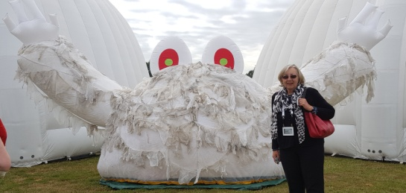
Innovate East Event 10th September 2019 – Trinity Park Showground, Ipswich
Global Thinking for our Collective Future

Annette Brown and I (MHWI) attended the first day of the three Innovate East event, meeting six other WI members there, mostly from Suffolk East and from Essex WI Federation. Sadly no one else from SWFWI had accepted the invite. The event was free, with free food and drinks available all day, including breakfast. We were warmly welcomed by Clare Pillinger, one of the AW speakers at Public Affairs Committee Science and Environment Day.

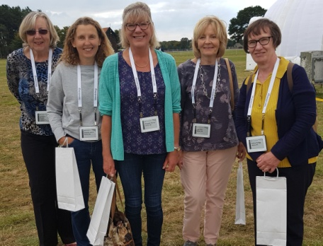
All sections of industry, not just connected with water and waste, along with school children, not for profit organisations and interested parties such as the WI were represented. After a welcome presentation from the day’s keynote speaker, Carol Voderman, we headed for our chosen Dash tent. The topic we discussed and worked on was:

Can we change customer behaviour on the use of wipes, sanitary products, fats, oils and grease (FOG) and make it stick?

After hearing from speakers about this issue, we split into groups and our table worked on how to tackle FOG’s. First we brainstormed to think about how best to make a sustainable behaviour change? We discussed how fast food businesses operated and also disposed of their FOG’s. The keyword to looking at implementing changes was Obama:

Objections
Behaviours
Awareness
Motivation
Action

We learnt about wipes Porcupine cages used in toilets by Northumbrian Water customers. These can prove to householders that their actions cause blockages. Anyone using a toilet needs to remember the 3 P’s – only pee, poo and loo paper can be flushed down a toilet. Similar traps can be used by eateries of all sizes to trap FOG’s. Some businesses install traps for such waste disposal but most of these are inadequate, don’t get used and/or emptied properly. Together we looked at ideas to raise awareness, along with practical solutions and business resources from all sides ie Water Companies, Environmental Health, River Authorities, Environment Agency, fast food establishments and customers.

At the end of the morning sessions we were treated to some yoga to move us around after being stationary. Food vouchers, wooden discs, enabled all to get free and drink at the outdoor Food Street at various vendors, except I chose to get my coffee from the only van that charged! There was a Water Bar to refill reusable water bottles and/or you could buy at reusable water bottle for a £5 donation to WaterAid. Annette and I checked out the various domes, including the AW pop up display. AW has a shop/advice centre in Newmarket after choosing Newmarket as a town to try new sustainable ideas with. They are happy to do give talks to WI’s.

The afternoon sessions, like the morning sessions, were split into two parts ending with our table coming up with a slogan, advertising campaign and a business plan to make a sustainable behaviour change for disposal of FOG’s. Annette came up with a slogan – Icebergs are shrinking but fatbergs are growing. This great slogan was used at the end of day plenary session in the main dome and was trending too over the three days!

There was food, drink and entertainment in the evening on each of the three days but we decided to return home. It was a very enjoyable day, we learnt a lot and do firmly hope that all our global thinking and ideas do lead onto playing a major part in our collective futures of a more eco and clean environment.
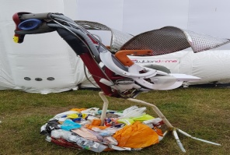

Gwen Williams
Chair
Public Affairs Committee

