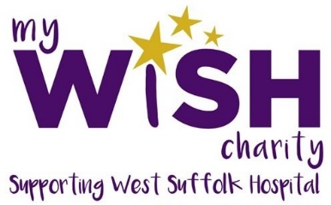
Following on from the success of our past craft projects for My Wish, including lap blankets, syringe driver bags and quilts for premature babies, they now need our help making wheat bags for cancer patients. These are used to warm hands so veins show more clearly for chemotherapy.

Wheat Bags

What you will need:
- fabric (something thick like corduroy, cotton or flannelette)
- fabric scissors
- sewing machine
- chopstick
- buckwheat 500g
- sewing needle
- thread
Please DO NOT include lavender as some people are sensitive to it.

How to make:
Using your fabric scissors, cut your fabric into two rectangle shapes. It doesn’t matter what size, as long as they are both the same. We used two pieces 10” x 8” with half inch seams. Finished size was 9” x 7”.
Place your two pieces of fabric face to face, with the wrong side of the fabric facing outwards. Sew the two pieces together with a seam allowance of approximately half an inch and leave an opening of about 2 inches so the wheat can be added in later. Reinforce the opening by doing a back stitch (stitching back and forward a few times) on each side of the opening.
Cut off the corners so that it doesn’t bunch up when you turn it inside out and you get nice points.
Turn it right side out. You can use a chopstick or a pencil to push out the corners into points.
Fill the bag roughly three-quarters full with wheat. You can make a funnel out of thick paper to make it simple, but you could just spoon it straight into the bag if you like.
Close opening with slip stitch.
Once you’ve made your wheat bags you can drop them off at one of our collection points, either at Rivendell, The Street in Sturmer or the WI Office.
Or you can deliver direct to the West Suffolk Hospital. To arrange delivery contact Sally Daniels (Wish Fundraising Manager) sally.daniels@wsh.nhs.uk

