Great Big Green Week
Appendix

Save the Planet Bingo
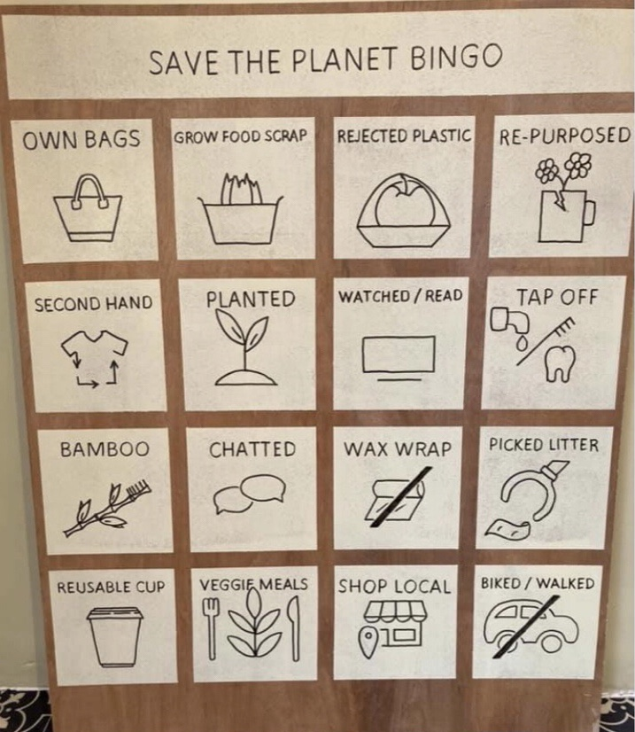
To be honest, we’re not sure how to play this game! It was shared online as a photo, so we thought it might be used as a talking point, unless your WI can work out how to use it in a different way!

If your WI would like tips on turning plastic bottles into flowers please contact Lesli for a pdf document with step by step instructions.

