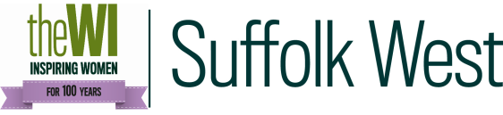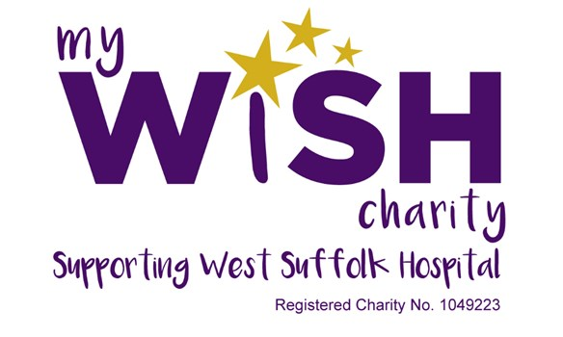
The WI Making for the My Wish Charity Project

Following on from our wonderful success in making syringe driver bags for West Suffolk Hospital, we have been asked for the following items:
Dementia blankets
Crocheted or knitted (in squares is fine) - these are about the size of a large, square headscarf (36” x 36” inches) and can be put across the knees or around the shoulders of elderly patients. Patients can also use them to relocate their beds in the ward by leaving them there as a marker – a task which can sometimes be a problem if you have dementia.
Premature baby quilts
These are about 24” x 24” and are laid on the top of the cots to stimulate the babies. Bold patterns (in black and white if possible) are requested as the babies will not see colour at such an early stage of development. Please use wadding from a good craft shop to meet safety standards.
Knitted teddies
These are for end of life patients. There is a pattern available on request or make one to your own pattern (about 14” tall). They provide comfort particularly for those who have no relatives to visit them.

If you would like to make any of these items, they can be delivered direct to the reception at West Suffolk Hospital for the attention of Sally Daniels or be sent to her at My Wish Charity, West Suffolk Hospital, Hardwick Lane, Bury St Edmunds, Suffolk IP33 2QZ.
There will also be a collection box in the Board Room at the WI Office, Park Farm where you can leave them for collection and delivery to the hospital.
Thank you for your continued support,
Linda Bevan, Sturmer and District WI,
Margaret Brackenbury, Creative Leisure Activities Sub Committee Chairman
Gwen Williams, Public Affairs Sub Committee Chairman

