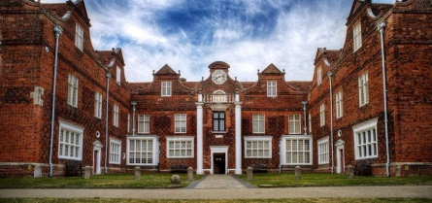
Christchurch Mansion (IP4 2BE)
Tuesday 9th June 2020
9.45am for 10am Tour
£5 per person

Christchurch Mansion in Christchurch Park, Ipswich is a treasure trove of exhibits spanning many centuries. We will meet at 9.45am in the foyer of the mansion and have arranged a tour for 10am.
This is a “get yourself there” visit – transport is not provided, however there are frequent Park & Ride buses which stop nearby (approx. 400m walk). There is limited parking for blue badge holders, but you must pre-register on 01473 433980.
Please note: There are no lifts to the upper floors and some floors are uneven. On a more positive note, there is a very good café and wonderful gardens to enjoy.
The tour will last approx. one and half hours. After you are free to explore the rest of Ipswich. We recommend the waterfront, Ipswich museum or the Women’s History Trail to name a few. Closing date for tickets is Wednesday 20th May 2020.
Remember! Booking represents a commitment to pay. Refunds only given if tickets can be re-sold.
"………………………… Please detach and return ………………………………
Christchurch Mansion – Tuesday 9th June 2020

WI …………………………………….………………. Contact Name…………………………….………..………
Tel……………………………………………………... Email……………………………………………………………..
Name | Mobile Number
..….. tickets required @ £5 per person.

Return to: SWFWI Office, Unit 11, Park Farm Business Centre, Fornham St
Genevieve, Bury St Edmunds, IP28 6TS | 01284 336645 | office.swfwi@gmail.com

