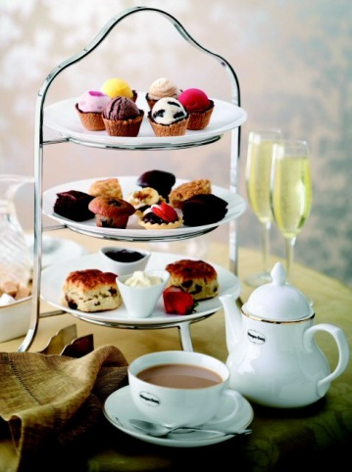
Afternoon Tea at The Guildhall
A Ritz style Tea, with a glass of Prosecco or orange juice served in the garden. Tea will be served in the Banqueting Hall.

Tuesday 14th July 2020
Drinks at 2.30pm & Tea served at 3pm
The Guildhall, Guildhall Street, Bury St Edmunds (IP33 1QB)
£18 per WI Member

This event is the second of two afternoon teas to celebrate the Centenary of our federation.

To continue the celebrations we will be hosting a Ritz style afternoon tea at The Guildhall, Bury St Edmunds. Weather permitting we will serve a pre tea drink in the garden, followed by a waitress served afternoon tea in the Banqueting Hall, after which members will have the opportunity to enjoy a guided tour of the Guildhall and the WWII Operations Room.

Dress code smart/casual.

Please remember! Bookings represent a commitment to pay. A refund will only be made if the ticket can be re-sold. Please contact the office if you can no longer attend.

………………………………………… Please detach and return……………………………………………
Afternoon Ritz Style Tea at the Guildhall - Tuesday 14th July 2020

WI ……………………………............................ Contact Name…………………………….…………………….
Tel ………………………………….................. Email address ……………………………………………………
Name | Phone Number | Dietary Requirements | Guildhall Tour? Yes/No

Please Invoice our WI for ………. tickets required @ £18 per member.

Return to: SWFWI Office, Unit 11, Park Farm Business Centre, Fornham St Genevieve, Bury St Edmunds, IP28 6TS
| 01284 336645 | office.swfwi@gmail.com

