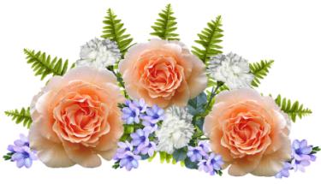
CENTENARY THANKSGIVING CELEBRATION
Saturday 5th September
St Mary’s Church, Bury St Edmunds
WE NEED YOU! We would like to fill St Mary’s Church with WI floral displays at the above event; therefore we are inviting WIs show off their floral skills.

If your WI would like to take part then there are several options:
- A pedestal arrangement (arrangements just needs to be in a pot)
- Window sill arrangements (8 inches deep and up to 4ft in length)
- An arrangement on the font steps (10 inches x 30 inches)
We hope to accommodate everybody’s requests but there are limitations, if we have too many of the same requests then we will allocate on a ballot basis.

There are no colour restrictions; we would love to see a riot of colour! Flowers from the garden would be ideal. We only ask you incorporate your WI name into the arrangement, this can be with a card or however you wish.

Bring your finished arrangement to St Mary’s on Friday 4th September (1.30-3.30pm). Collection will take place on Monday 7th September – the church will then have the benefit of your wonderful work for the Sunday, but we do understand you may wish to take your arrangements with you after our service on the Saturday.

Please return the slip below by 1 July 2020. For queries please contact Margaret Brackenbury by email: margbrackenbury@btinternet.com
………………………… Please detach and return ………………………………
Centenary Thanksgiving Celebration Flower Arrangements

WI …………………………………….………………. Contact Name…………………………….………..………
Tel……………………………………………………... Email……………………………………………………………..
Preferred arrangement (pedestal/window sill or font) ………………………………………………
…………………………………………………………………………………………………………………………………….
Return to: SWFWI Office, Unit 11, Park Farm Business Centre, Fornham St Genevieve, Bury St Edmunds, IP28 6TS | 01284 336645 | office.swfwi@gmail.com

